Documentation of Gesture-Based Patient Communication System

1. Introduction
A Gesture-Based Patient Communication System is an assistive healthcare technology designed to help patients who are unable to speak or move freely communicate their needs effectively. This system is mainly useful for patients suffering from paralysis, speech disabilities, neurological disorders, or temporary physical injuries. The project enables communication between patients and caregivers through simple hand gestures or body movements.
The system uses sensors to detect gestures and converts them into meaningful messages. These messages are displayed on a screen or converted into voice output, helping doctors, nurses, and family members understand the patient’s requirements quickly.
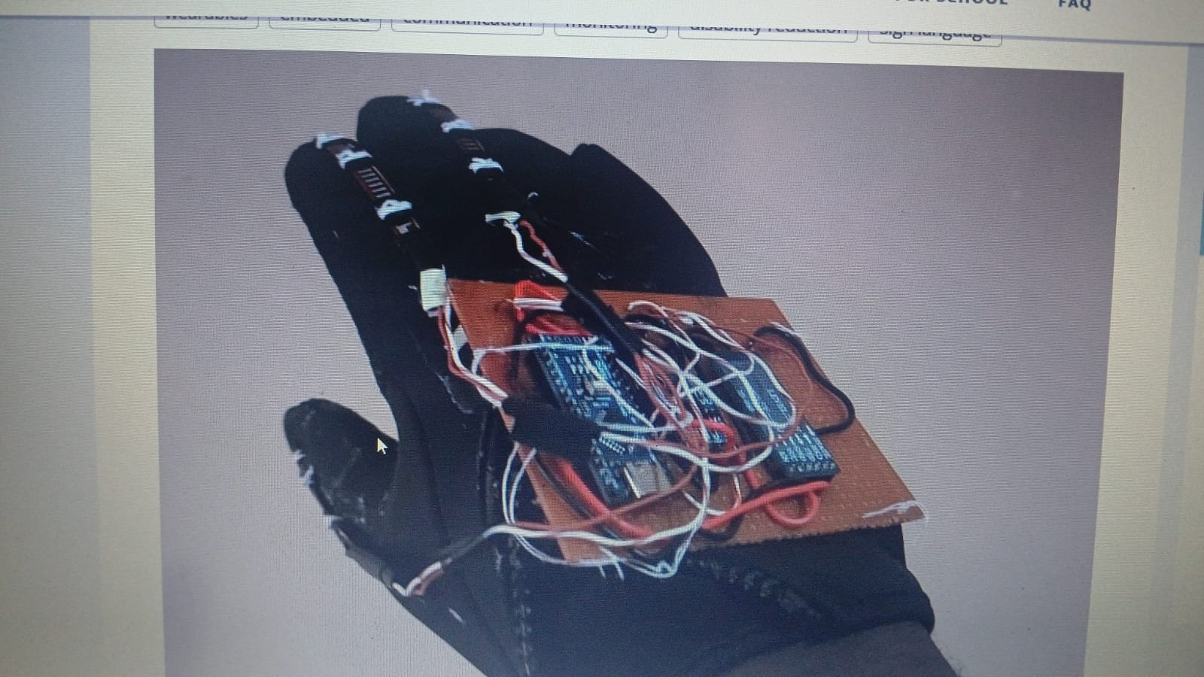
Modern versions of the system may integrate artificial intelligence and machine learning to improve gesture recognition and adapt to different patient movements. However, challenges such as sensor sensitivity, gesture misinterpretation, and limited movement ability in some patients may affect system performance.

2. Objectives
- To help physically challenged or speech-impaired patients communicate easily.
- To reduce communication barriers between patients and caregivers.
- To provide quick and accurate patient assistance.
- To improve patient comfort and independence.
- To create a low-cost and user-friendly healthcare solution.

3. Components Required
Hardware Components
- Arduino Uno / Raspberry Pi
- Flex Sensors
- Accelerometer Sensor
- LCD Display
- Speaker or Buzzer
- Bluetooth Module (optional)
- Power Supply
- Connecting Wires
- Gloves for sensor placement
Software Requirements
- Arduino IDE
- Embedded C / Python Programming
- Serial Monitor Software

4. Working Principle
The system works based on gesture recognition. Sensors attached to a glove detect finger or hand movements. These movements generate electrical signals that are sent to the microcontroller.
The microcontroller processes the received signals and compares them with predefined gesture patterns stored in memory. Once a gesture is recognized, the corresponding message is displayed on the LCD screen or announced through a speaker.
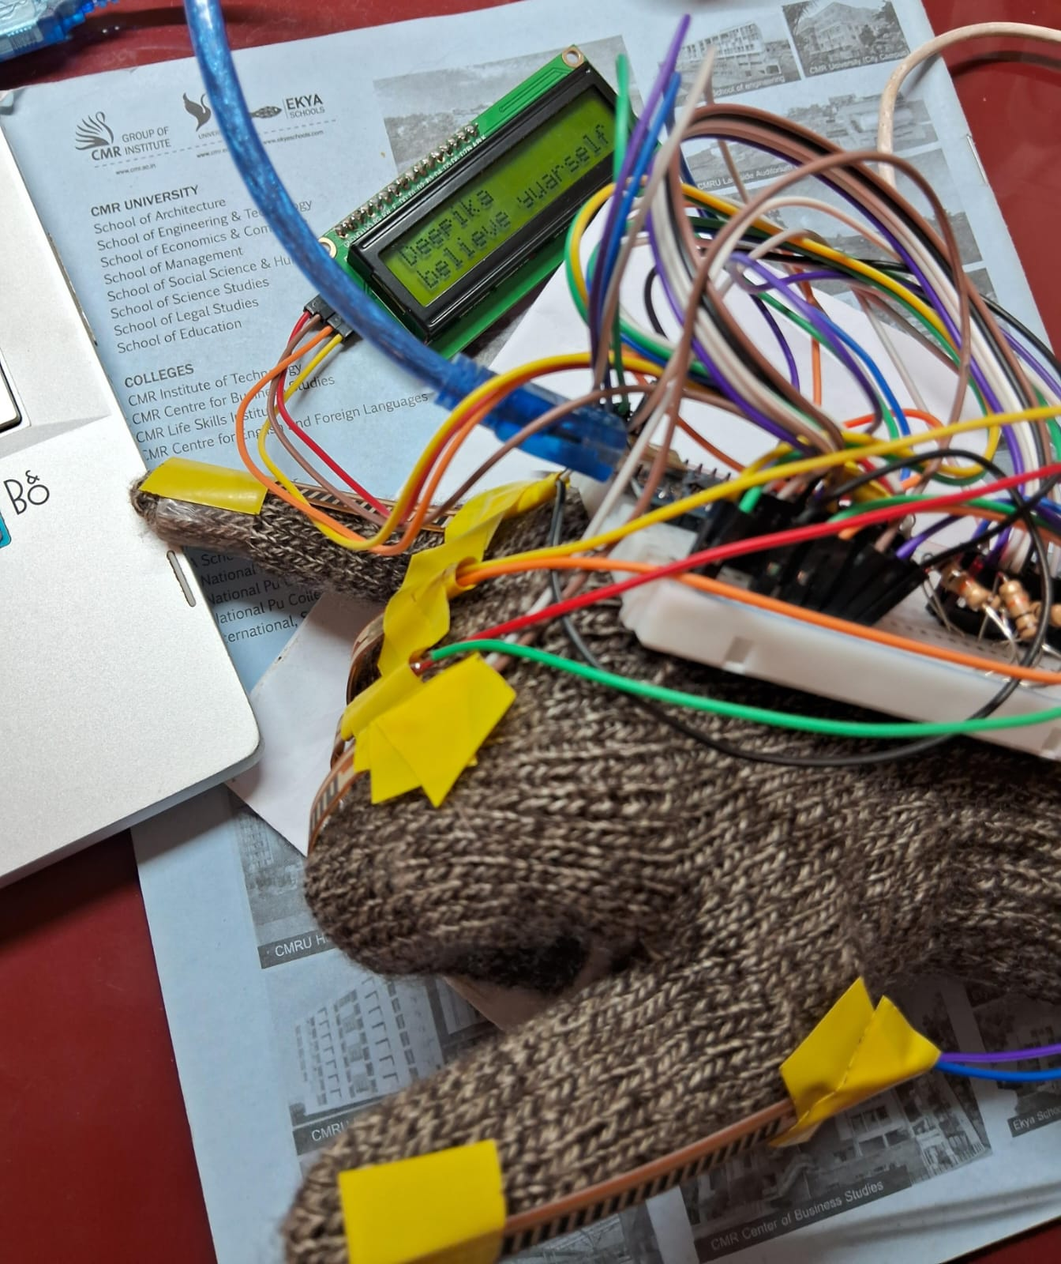
For example:
- One finger bend → “Need Water”
- Two finger bend → “Call Doctor”
- Hand tilt → “Emergency”
Wireless modules can also send notifications to smartphones or hospital systems.

5. System Architecture
The architecture of the system includes:
- Input Unit – Sensors detect gestures.
- Processing Unit – Arduino/Raspberry Pi processes signals.
- Output Unit – LCD display or speaker provides output.
- Communication Module – Bluetooth/Wi-Fi transmits alerts.
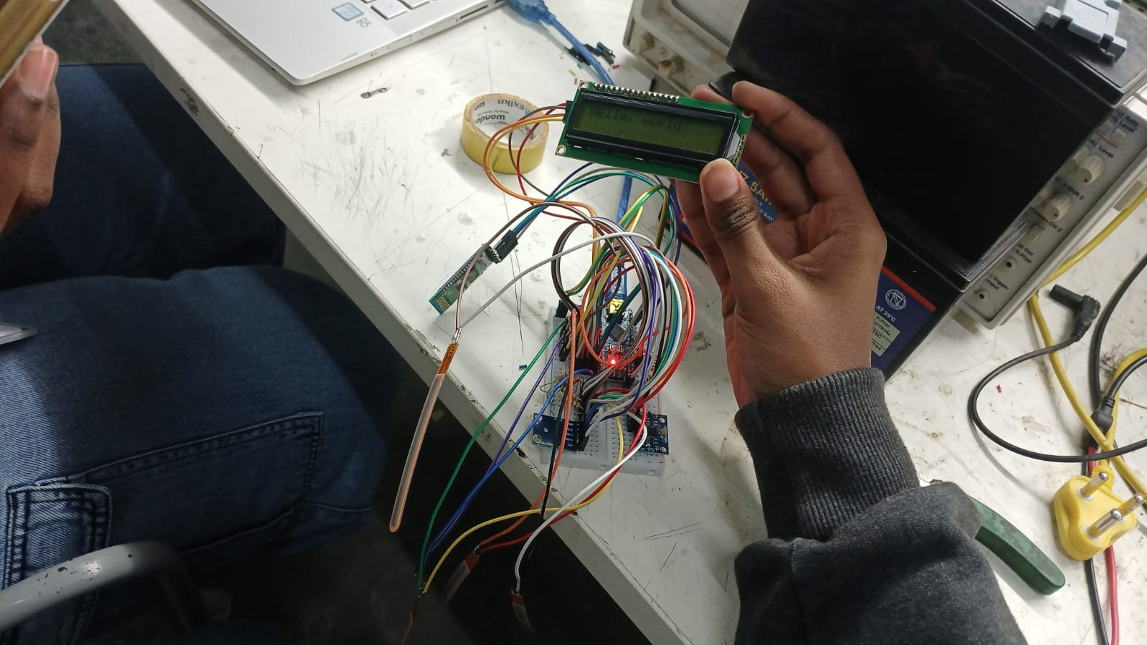

6. Advantages
- Easy communication for disabled patients
- Faster response from caregivers
- Portable and cost-effective
- User-friendly system
- Reduces misunderstandings

7. Disadvantages
- Sensor calibration may be required
- Gesture recognition errors can occur
- Limited use for patients with severe movement restrictions

8. Applications
- Hospitals
- Rehabilitation centers
- Home healthcare
- Elderly patient care
- Assistive communication systems

9. Future Enhancements
- AI-based gesture recognition
- Mobile application integration
- IoT-enabled monitoring
- Multi-language voice support

10. Conclusion
The Gesture-Based Patient Communication System is an innovative and efficient healthcare solution that improves communication for physically challenged patients. It ensures better patient care, quick medical response, and enhanced comfort by enabling patients to express their needs through gestures. This system plays an important role in modern healthcare and assistive technology.

